**BUMP INTEGERATOR:**

Impacts of Unevent Pavements in INDIA:

1. Economic Impacts:
2. Poor Quality roads require frequent maintance and repairs, - Govement money wastage.
3. Affect Transportation of goods, supply chain and buissness. – increased transportation cost,delay and reduce competitiveness.
4. Rough Roads cause wear and tear to vehicle, leading to high maintainance cost.
5. Traffic Jam due to poor roads –Time wastage , productivity loss.
6. Safety and Health Impact:
7. Poor roads lead to accidents, especially for two- wheelers,
8. Traffic Jam on uneven roads, lead to increased fuel consumption and air pollution.
9. Bad Roads can cause stress and fatigue among drivers
10. Pedestrians and Cyclsit face high risk of accident due to uneven pavements.
11. Social Impact:
12. Bad road cause delay in access to services like healthcare, education and emergency services. – **Rular areas will suffer more**.
13. Citizens Quality of life affected – constant discomfort, noise pollution, - especially for **senior citizens**
14. Enviromental Impact:
15. Poor roads can cause soil erosion – affect agriculture and natural Habitat
16. Improper drainage on poor uneven roads can cause Water logging and water Pollution.
17. Tourism and Development Impact:
18. Poor roads can deter tourists, - affecting Tourism Industary and local economics relying on tourism-revenue
19. High Quality road inftastructure vital for Economic Development – Good roads attract investment, industries, and buissness creating jobs opportunity.
20. Long Term Impact:
21. Continued neglect of road infrastructure will widen gap between urban and rural areas, hindering balanced development.
22. Funds used on frequent repair of the road can be used for more sustainable infrastructure projects, - hinder overall progress of the country.

**VEHICLES WITH ACCIDENT ALLERT SYSTEM :**

1. [**Google Pixel’s Car Crash Detection Feature**:](https://in.mashable.com/tech/63126/google-pixel-car-crash-detection-feature-finally-arrives-in-india-how-to-enable-how-it-works-and-mor)
2. Available in Google Pixel Phone starting from Pixel 4A12 **.**
3. It uses the phone’s location, motion sensors, and nearby sounds to detect a possible car crash. [If it detects an accident, it automatically contacts emergency services and shares your location](https://www.91mobiles.com/hub/google-pixels-car-crash-detection-available-india/)
4. Price to this phone is Rs. **99,900.**



1. **Arduino Based Vehicle Accident Alert System**:
2. This system uses GPS, GSM, and an accelerometer. [The accelerometer detects the sudden change in the axes of the vehicle and the GSM module sends an alert message to a predefined mobile phone with the location of the accident](https://circuitdigest.com/microcontroller-projects/arduino-based-accident-alert-system-using-gps-gsm-accelerometer)

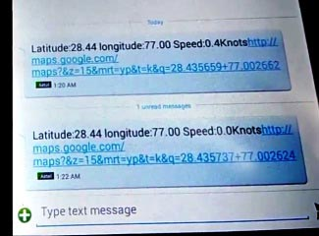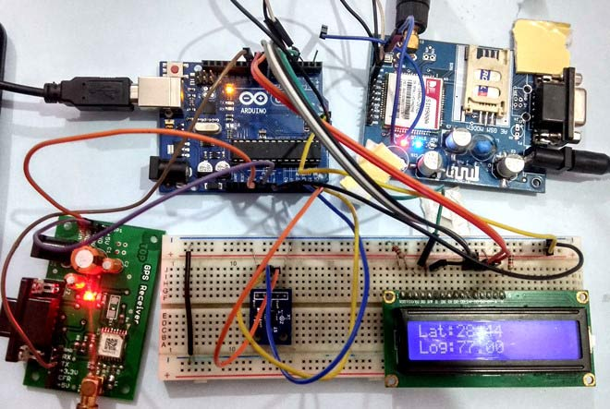 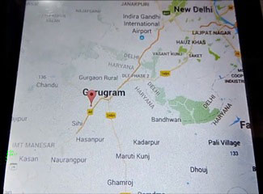

1. **On-Board Units in Vehicles**:
2. an electronic device installed in a vehicle that records traffic and driving data and can connect to roadside and satellite navigation systems.
3. Some vehicles are equipped with on-board units (OBUs) that can detect accidents. [For example, the eCall system developed by the European Commission is compulsory to deploy in each vehicle developed after 2015](https://www.mdpi.com/2071-1050/14/13/7701).
4. The cost of vehicles with On-Board Units (OBUs) can vary greatly depending on the make and model of the vehicle. [For instance, the Maruti Wagon R, which may have an OBU, is priced between Rs 5.55 lakh and Rs 7.43 lakh](https://www.cardekho.com/maruti/wagon-r).

